## **Week – 6 REACT**

**ASSIGNMENT – 1**

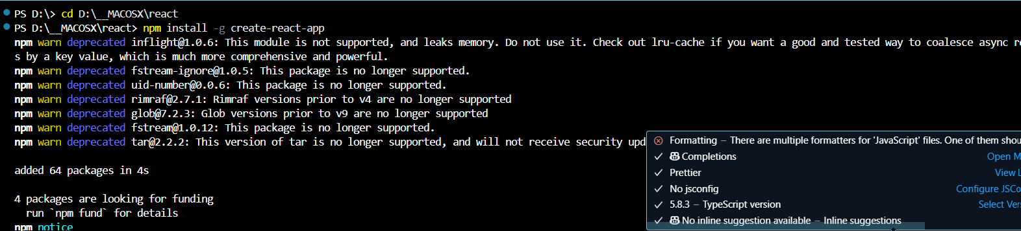

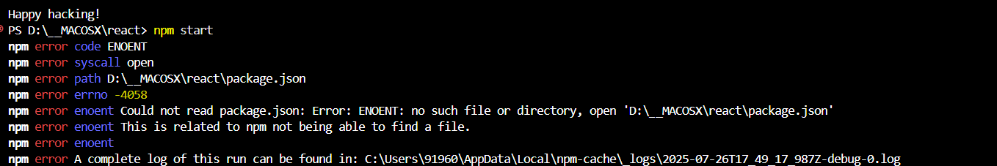

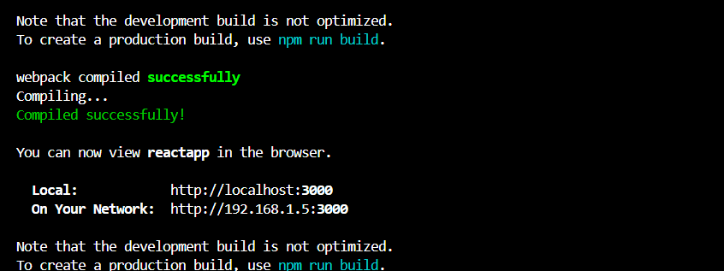

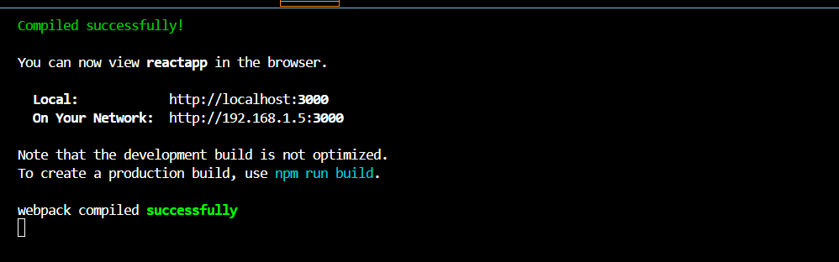

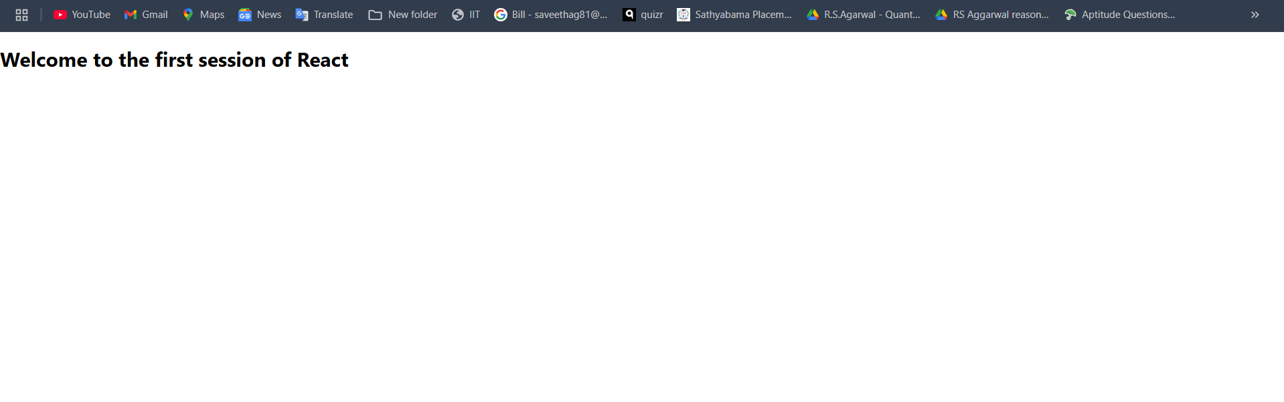

**ASSIGNMENT – 2**

1. Working Directory after Creating an Student App

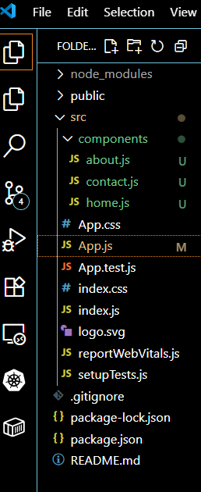

**HOME.JS CODE:**

import React from 'react';

function home() {

  return (

    <div>

      <h2>Welcome to the Home page of Student Management Portal</h2>

    </div>

  );

}

export default home;

**ABOUT.JS Code**

import React from 'react';

function about() {

  return (

    <div>

      <h2>Welcome to the About page of the Student Management Portal</h2>

    </div>

  );

}

export default about;

**CONTACT .JS CODE**

import React from 'react';

function about() {

  return (

    <div>

      <h2>Welcome to the About page of the Student Management Portal</h2>

    </div>

  );

}

export default about;

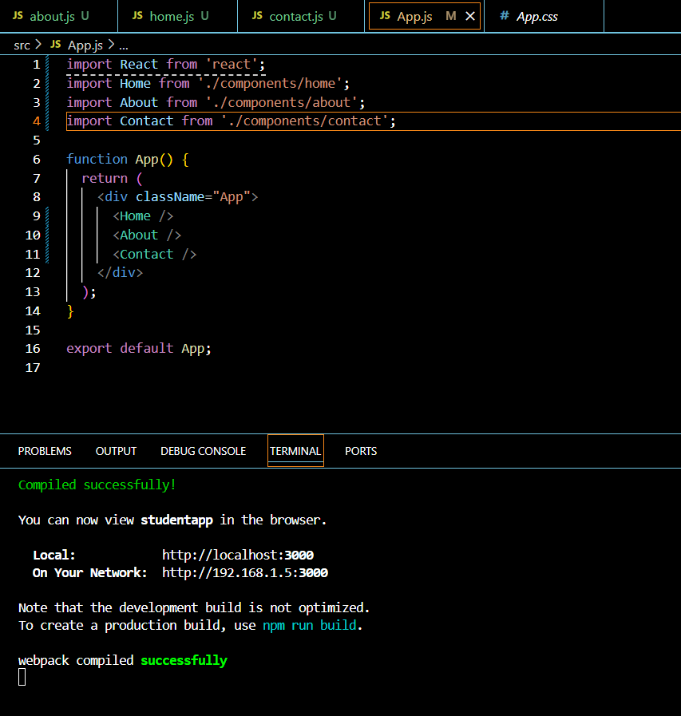

OUTPUT :

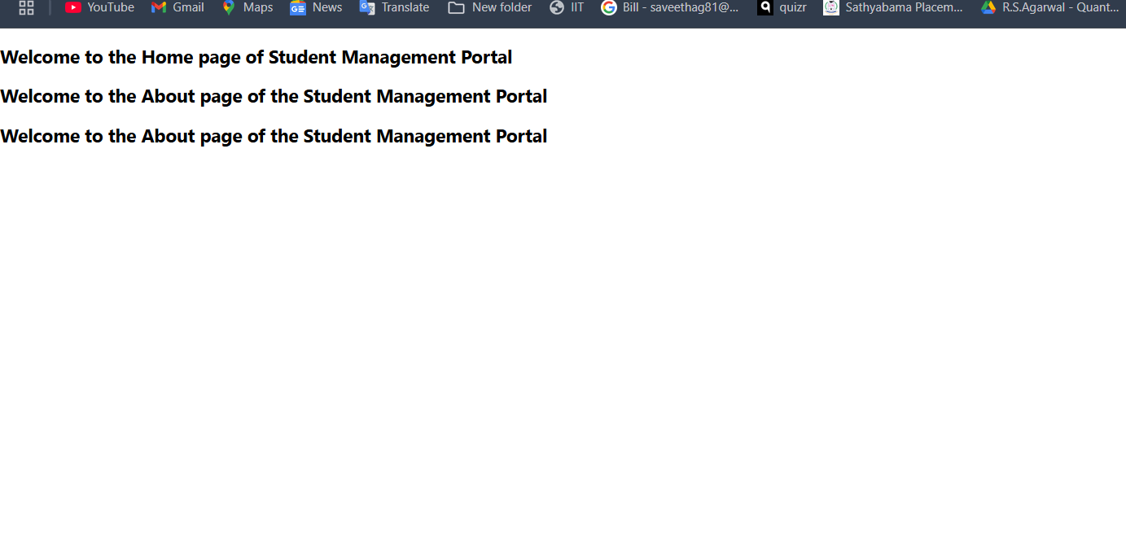

**ASSIGNMENT – 3**

**Creating the calculate react app**

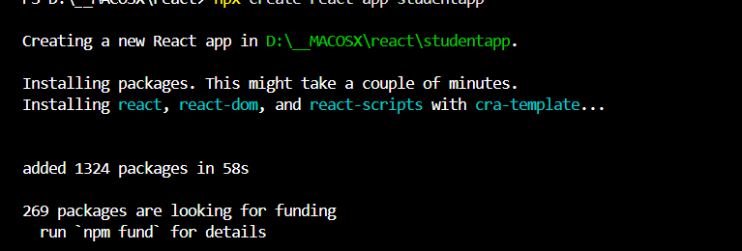

**Working directory:**

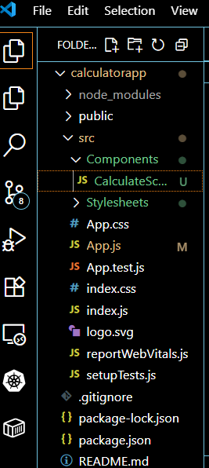

**Calculate.js**

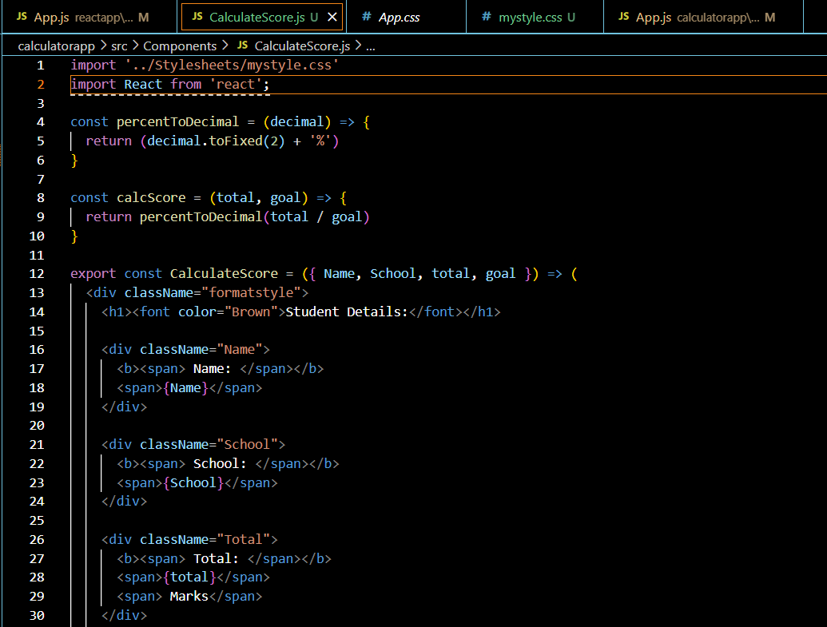

**Style.css**

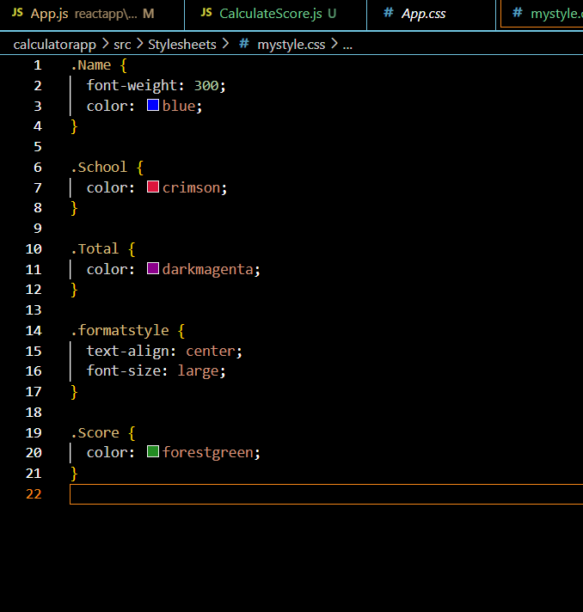

Output: 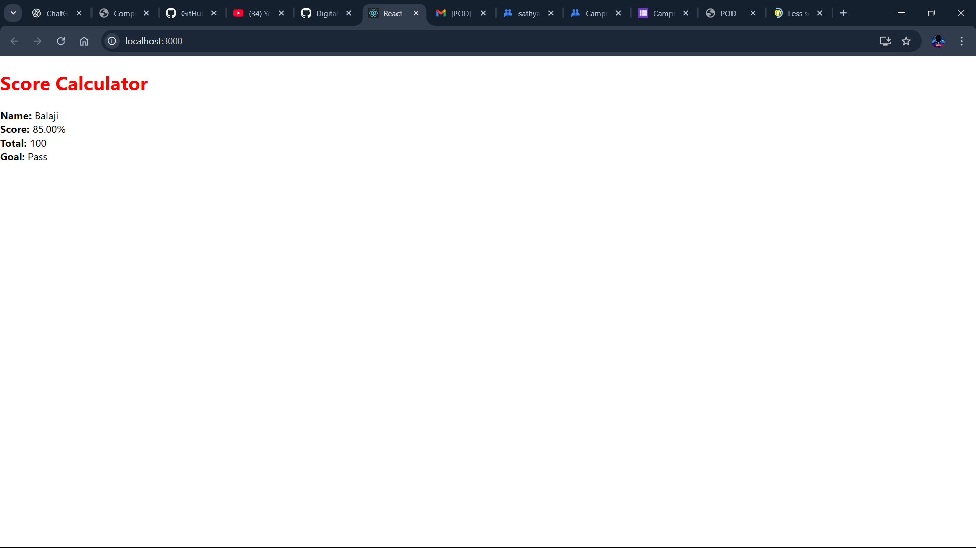

**ASSIGNMENT – 4**

**Creating blogapp :**

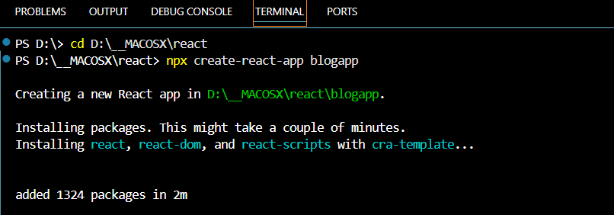

**Working Directory :**

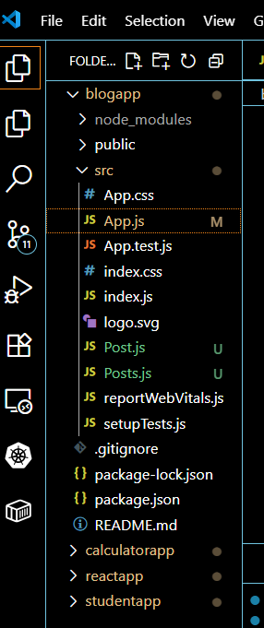

1. **Create a new class based component named as Posts inside Posts.js file**

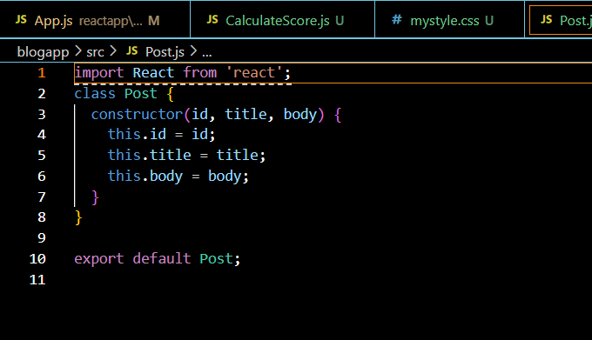

1. **Initialize the component with a list of Post in state of the component using the constructor**

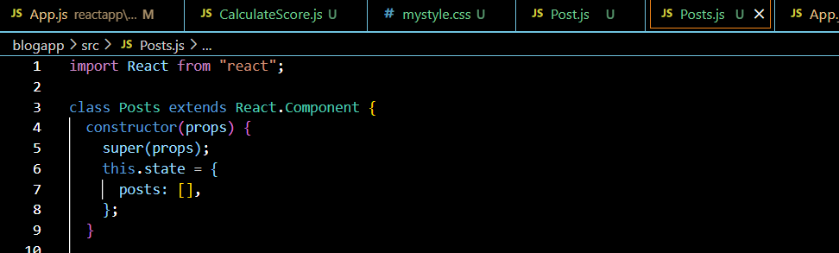

1. Create a new method in component with the name as **loadPosts()** which will be responsible for using Fetch API and assign it to the component state created earlier. To get the posts use the url (<https://jsonplaceholder.typicode.com/posts>)

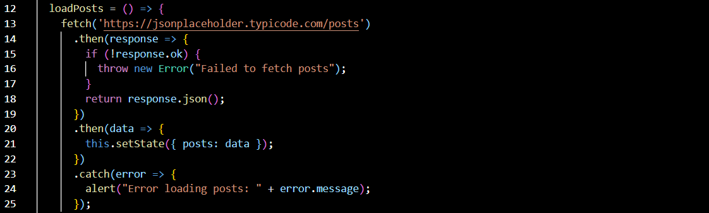

1. Implement the **componentDidMount()** hook to make calls to **loadPosts()** which will fetch the posts

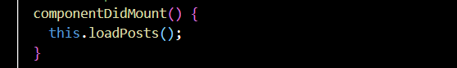

1. Implement the **render()** which will display the title and post of posts in html page using heading and paragraphs respectively.

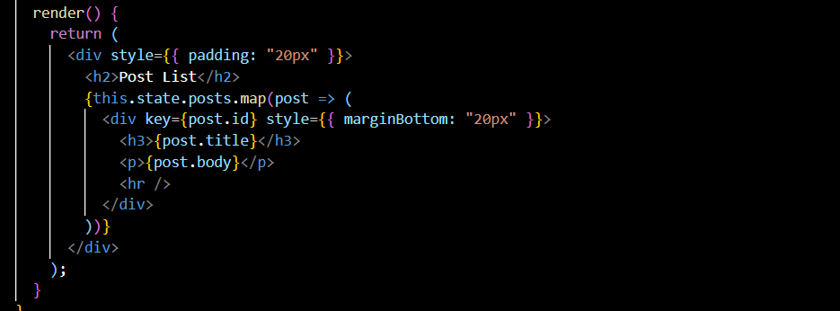

1. Define a **componentDidCatch()** method which will be responsible for displaying any error happing in the component as alert messages.

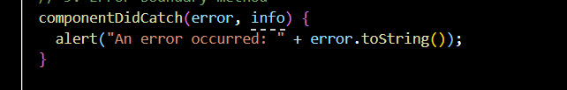

1. Add the Posts component to App component.

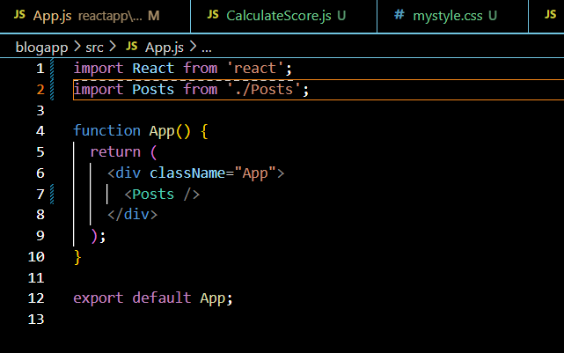

**Output :**

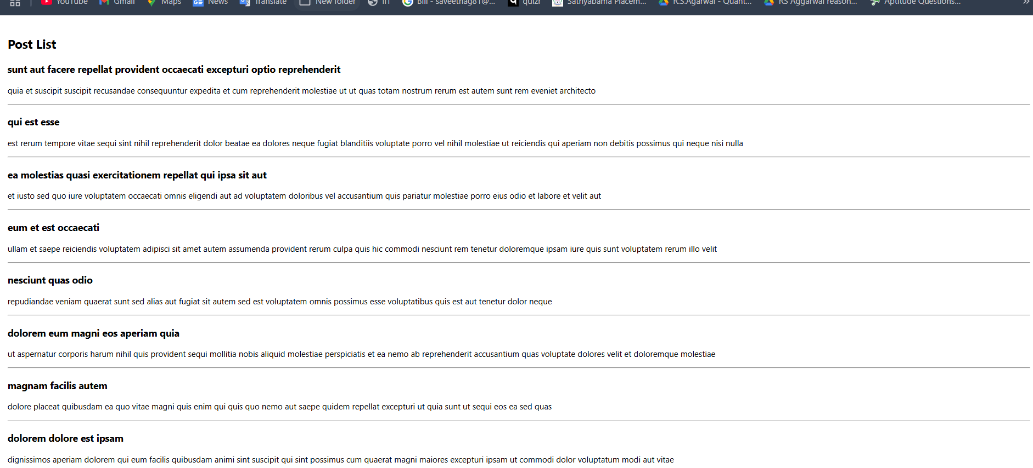

ASSIGNMENT – 5

1. **creating the cohortstracker app**

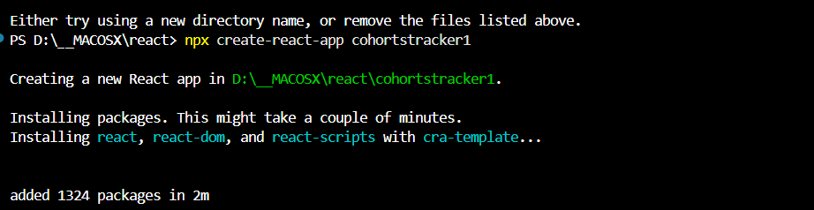

1. Create a new CSS Module in a file called “CohortDetails.module.css”

Define a css class with the name as “box” with following properties

*Width = 300px;*

*Display = inline block;*

*Overall 10px margin*

*Top and bottom padding as 10px*

*Left and right padding as 20px*

*1 px border in black color*

*A border radius of 10px*

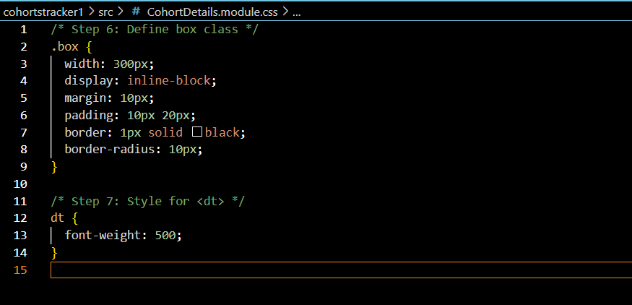

1. Define a css style for html <dt> element using tag selector. Set the font weight to 500.

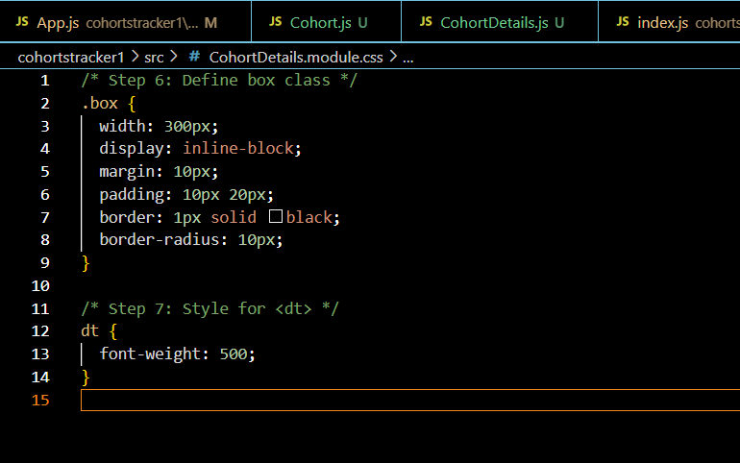

1. Open the cohort details component and import the CSS Module

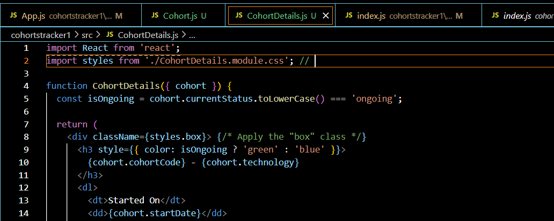

1. Apply the box class to the container div

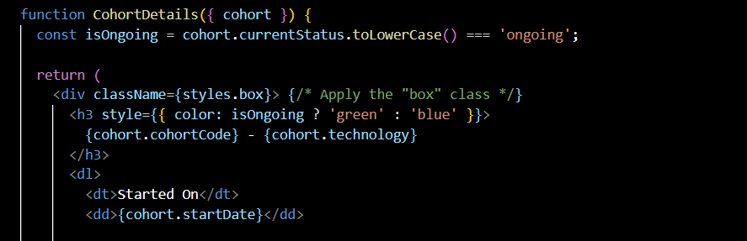

1. Define the style for <h3> element to use “green” color font when cohort status is “ongoing” and “blue” color in all other scenarios.

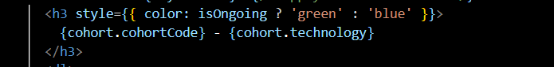

1. OUTPUT

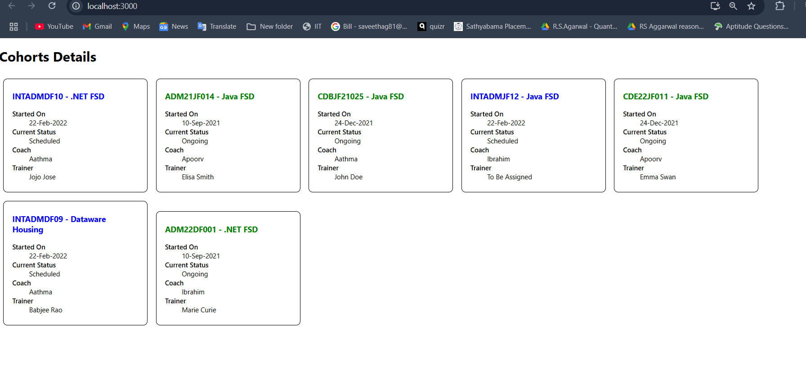

Working Directory :

